Hints and tips on using the UsynligO app
When you install UsynligO on your mobile phone it will ask you to 'register' - either by creating your own Login, or by your existing Google passwords. Either works fine - so it’s up to you which you prefer.
TOP TIP: Its best to register and login for the first time at home before you set out, in case you can't remember the relevant login details.
The app will also ask to access 'Location Data' - you will need to grant this for the app to work.
TOP TIP: On an iPhone this can be done using 'Settings > UsynligO > Location > Always'. On Android the follow link explains how: Android Location Instructions.
Before logging on to the app please make sure you have set your phone to never sleep otherwise you will drop out of the event before you have finished. On an Andriod phone go to settings, then click on display & brightness, then select sleep and set to never.
Once you are logged in you will get a screen like the one shown below.
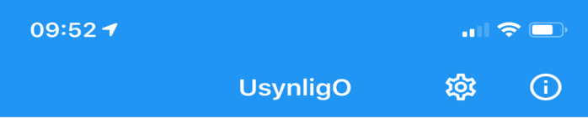
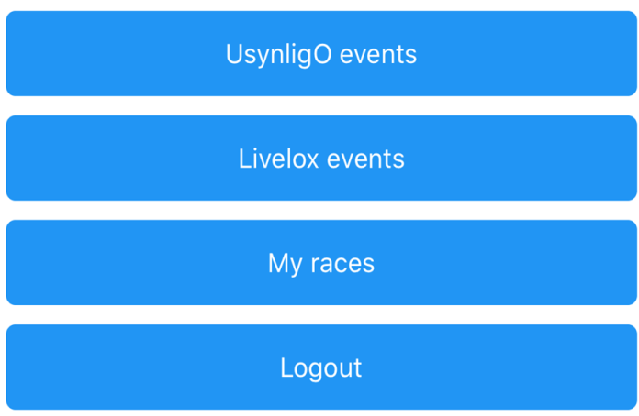
UsynligO depends on GPS access and an accurate GPS. If UsynligO does not detect the control points or if the compass or direction hints are inaccurate, you may need to check the following:
- Verify that you have granted UsynligO “Always” access to your location.
- Do NOT enable any power save program on your phone. Some phones will not update the GPS when the phone is in power save mode and the app is in the background.
- In settings set the control radius to 15 meters and minimum GPS accuracy to 100 meters. These settings should be adequate for most smartphones.
- Open the map application (i.e. Google maps) on your phone and validate that the compass is calibrated and that the GPS works ok.
- Be aware that the compass will not work correctly if you have a case with a magnetic lock.

