Using Sportident (Si) from a Scout’s viewpoint.

- Just prior to the Start box will be a “Clear” station for you to dib at first to clear all previous data from the micro-chip. The Start team will probably remind you to do this and then they will ask you to put the dibber in to the “Check” unit.
- When you are allowed to set off please ensure that you then dib the “Start” box before setting off on your Course, otherwise you will shown as dns (did not start) in the final Results and will have expended all that energy for nothing as you are disqualified!
- When you arrive at a Control, there will be a Kite there hung from the Si yellow stake with a 3-digit number displayed below the Si Station. If the station displays the correct control numbers (remember that there will be other controls that you may come across that are not for your course) then dib into the Si Station (See Fig 1 below) wait to see the flashing lights and listen for the “beep” and continue to the next control.
Fig 1.
Sport Ident Electronic Card (Dibber) | 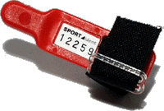
Sport Ident Station | 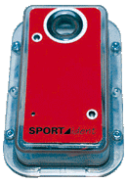

- If you realise that you have punched a wrong control, ignore the mistake and continue, the Si software will allow for this. Similarly, if you dib out of sequence, the error will be ignored providing you go back and subsequently re-dib in the correct sequence. For example, you dib at No.5 and realise that you have not dibbed No.4. Provided that you go back and dib at No.4 and then re- visit No.5 and dib again, then Si will allow for this when calculating your results. However, if you fail to dib at No.5 after going back and dibbing No.4, then it will show up in the Results as “missing No.5” and a 5min time penalty will be added. Control sites stakes will have manual needle punches attached to the yellow stakes to punch (to prove that you have visited a particular control) the map should the Si units fail.

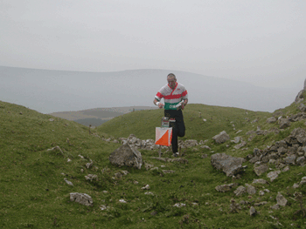
Fig 2. - Dibbing at a Control
- The time is stored in the micro-chip in the dibber, so then at the Finish (having visited all the Control sites on your course) you go to the “Download” table to download your dibber. You will then be given a tear off slip that will have on it your names, scouts, course, and overall time taken + your “splits” times to each control. The tear-off slip will show Mid Wales Orienteer’s’ website and will advertise the next Mid Wales Orienteer’s event. Remember, you are welcome to come along to any of the Club’s “Local” events.

Bill Marlow

