


Do you like the outdoors?
Do you like maps?
Do you like treasure hunts?

IF YES THEN COME AND HAVE A GO AT


SUNDAY 21st June 2015

Could you navigate around this course if so then come along and enter our next All Wales Scout Competition open to all Scouts and Explorer Scouts, to be held on 21st June 2015 at Nash Woods, Presteigne Powys.

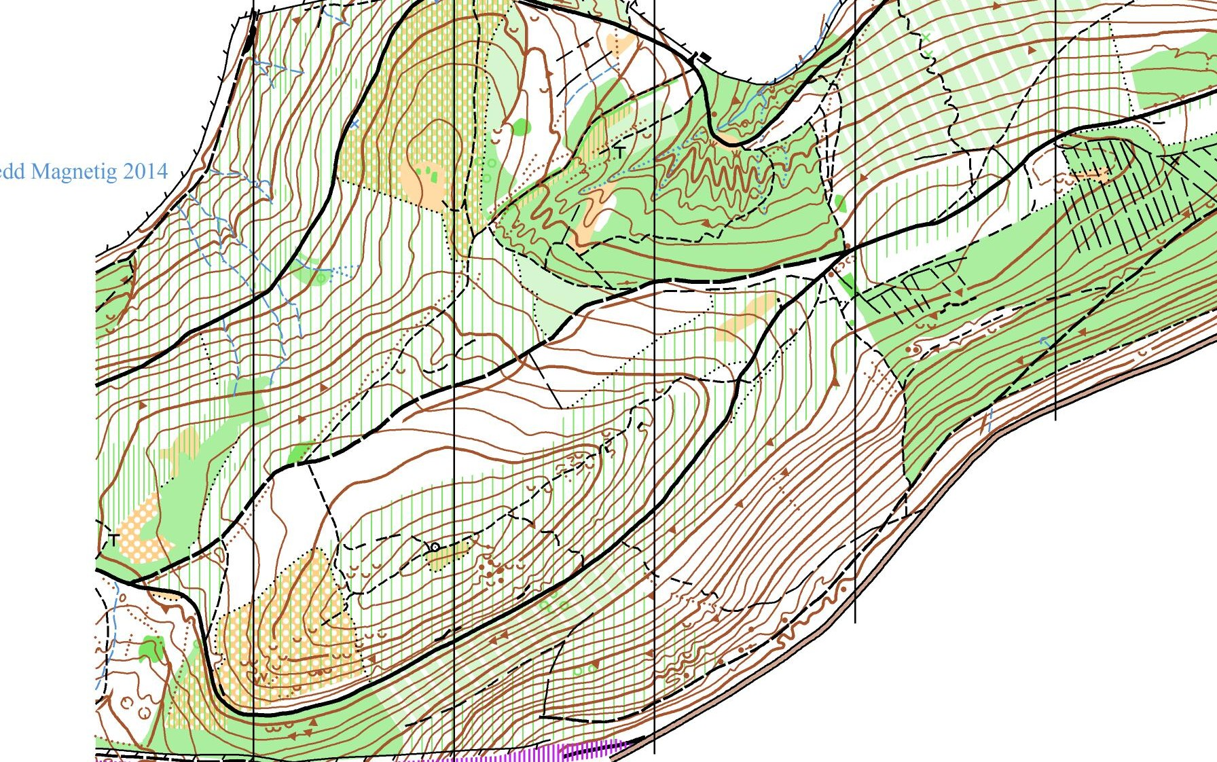

For details please see one of the following websites, Scouts Wales http://www.scoutswales.org.uk/activities/orienteering or Mid Wales Orienteer's website http://www.mid-wales-orienteers.org.uk/info/category/scouts.

If you require any further information contact Terry Smith on (01982570792)

