


Do you like the outdoors?
Do you like maps?
Do you like treasure hunts?

IF YES THEN COME AND HAVE A GO AT


SUNDAY 12th June 2016

Could you navigate around this course if so then come along and enter our next All Wales Scout Competition open to all Scouts and Explorer Scouts, to be held on 12th June 2016 at Nash Woods, Presteigne Powys.
Medals will be awarded for all courses for those individuals and teams finishing in the first three places.

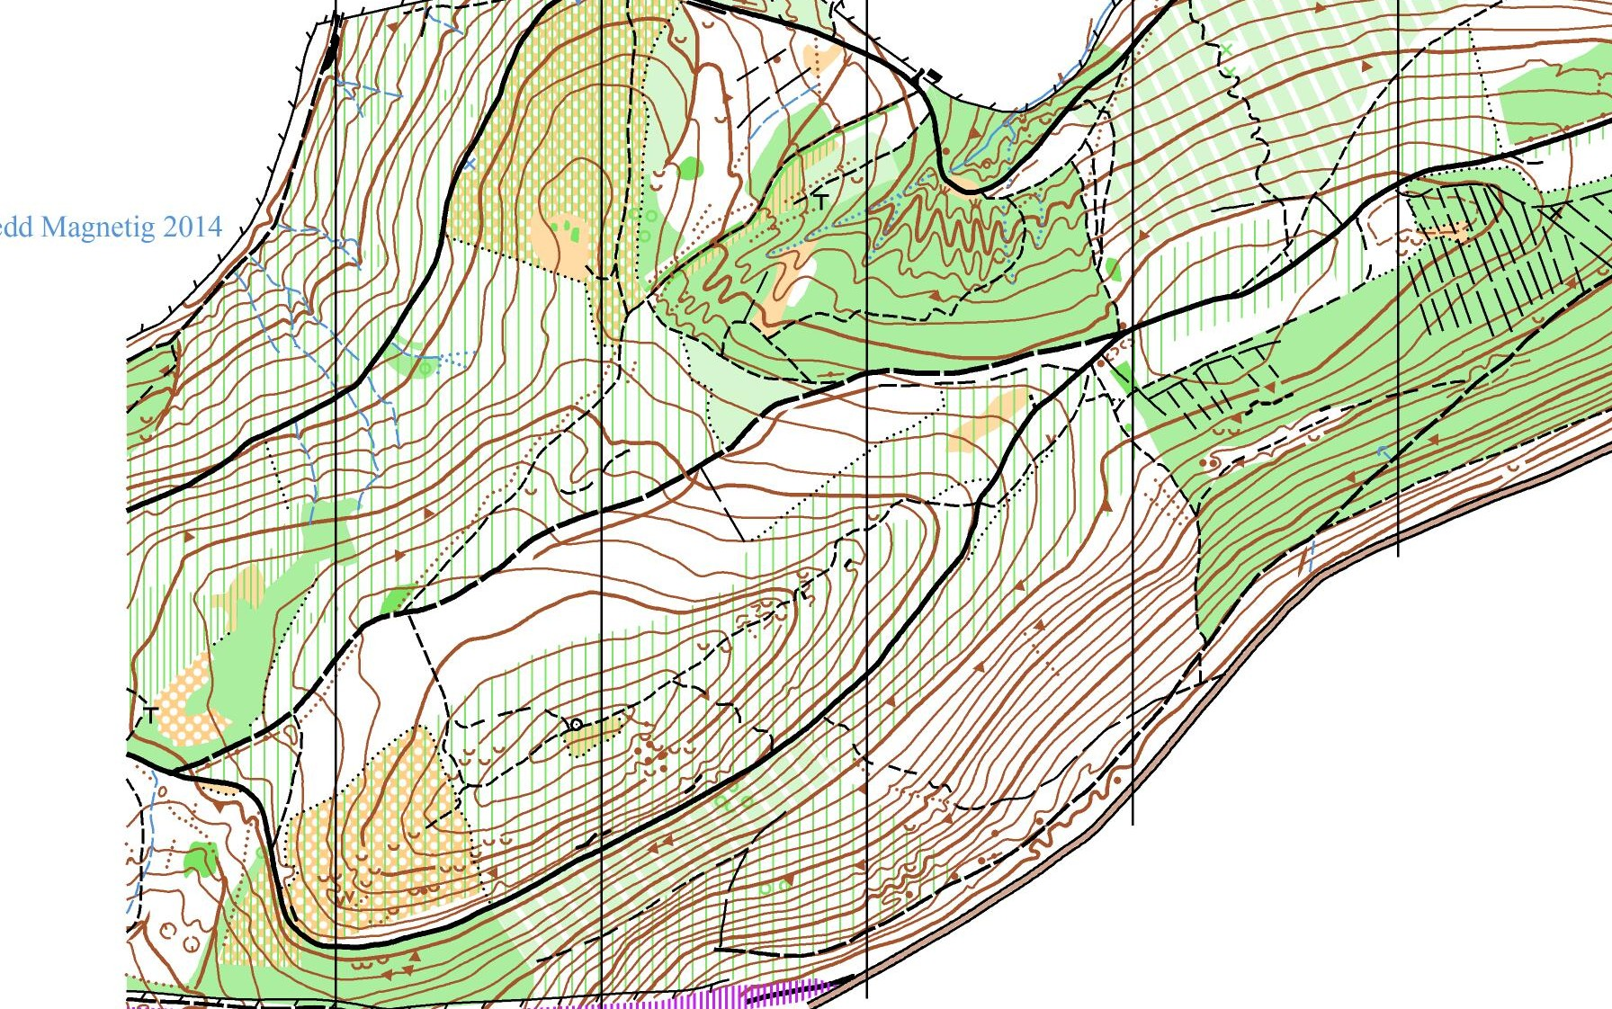

For details please see one of the following websites, Scouts Wales http://www.scoutswales.org.uk/activities/orienteering or Mid Wales Orienteer's website http://www.mid-wales-orienteers.org.uk/info/category/scouts.

If you require any further information contact Terry Smith on (01982570792)

