A MISSING COMPETITOR - EMERGENCY SAFETY PROCEDURES

- Preparation and Prevention. All of the guidance recognises that sound planning and organisation, before the event and on the day, will go a long way to ensure that the event is safe.

- Contingency Planning: planning for any event that might happen. Consult event Risk Assessment Form:
- Communications – mobile phones, radios, loud hailer – check to make sure they work in the area.
- Search teams – have at least 1 pair of orienteers available who can go out immediately.
- Emergency Sack – contains 1st Aid kit, emergency shelter, dry clothing and food that is available to a distressed person.
- Press – if an incident occurs then use Club Press Officer to speak to the Press and refer them to BOF Office.

- Event officials and Registration Teams need to know:
- Location and telephone number of nearest manned A&E hospital.
- To send a guide to meet any Ambulance.
- Suitable landing site if Air Ambulance is called.
- If Air Ambulance called find out which A&E it is being sent.

- Concern Grows – Search Looks Likely. There is understandable caution about raising the alarm and organising emergency services in response therefore the most difficult decision is to initiate the search. BOF Rules make it clear that the responsibility for this decision lies with the Organiser. The reality is that this is likely to be a joint decision with the Controller and Planner.

- The likely scenarios are:
- Reported Injured
- Late
- Failed to Download
- Missing (& Injured)
Step 1 -  Informing the Decision |  | There is a need to ensure that a methodical approach is taken to the situation. There is a need for thoroughness in each Step and firm control in what could be a difficult situation
 | Step 2 -  Preparing the Search
 |  | Step 3 -  Conducting the Search
 |  |  | Step 4 -  Concluding the Search

Step 1 -  Informing the Decision | Step 2 -  Preparing the  Search | Step 3 -  Conducting the Search | Step 4 -  Concluding the Search

- Scenarios & How do we find out? Factors influencing the decision? Are we concerned?
- Confirm the competitor is actually late/missing - cross check Registration list, Start list/SI Start unit, Finish SI unit and Download.

How do we find out? | Scenario
How do we find out? | Reported Injured | Late | Failed to Download | Missing (& Injured)
- Someone tells us | √ | √ |  | √
- Results team identify unaccounted for competitor |  | √ | √ | √
- Car left at end of event |  | √ |  | √
- No car left at end of event |  |  | √

- Reported Injured – arguably this is the most straightforward. Despatch 1st aid team to casualty – task emergency services to enable evacuation if required.
- Late – start to answer factors required to make decision. Contact friends/relatives/spectators/other competitors. Warn search teams. Decide time when competitor is to be deemed missing.
- Failed to Download – Contact friends/relatives/ spectators/other competitors.
- Missing (& injured) – Initiate search. An injured, unconscious competitor lying in thick terrain is the worst case scenario. It will demand considerable resources – more than available – and take a long time to thoroughly work through the area.

FACTORS INFLUENCING THE DECISION

Who | Age | Course
Experience of competitor | What were they wearing | How long have they been out
Nature of terrain | Weather now & forecast | Amount of daylight remaining
Density of competitors still out | Any medical condition | Car left in car park

ARE WE CONCERNED?
- If yes – move on to Step 2. Start log – times, actions, details, etc.
- If no – when will the situation be reviewed? Is the delay appropriate given the age of the competitor, weather & remaining daylight?
- Remember – with a missing person, time is against you, weather is against you and daylight is against you. Bear in mind excessively time-consuming nature of a search hence need for early decision to start. A decision needs to be made fast.
- The local Police will appreciate early notice even if they are not being requested or formally tasked at that stage.
Step 1 -  Informing the Decision | Step 2 -  Preparing the  Search | Step 3 -  Conducting the Search | Step 4 -  Concluding the Search

- Establish the Emergency Search structure.

= Communications  (min of 4 radios/mobile phones) | Control (Controller)
- Overall control
- Coordinate Response
- Keep out of detail to ensure oversight
- Plan ahead & troubleshoot
- Keep all below up to date
 | 
Information  (Registration) | Search (Organiser) | Liaison  (Planner)
- Ascertain the factors in Step 1 & keep under review  - Call out other club members to help  - Organise catering for search all involved  - Maintain Incident Form & Search Report | - Organise Search Pairs incl nominated Leaders & 1st Aid    Issue Emergency Sacks & Radios (incl spare batteries)  - Provide maps of area/course  - Provide keys for access routes  - Provide SI key to interrogate boxes  - Coordinate search  - Record & Report progress | - Inform Emergency Services (Police, Ambulance, Mountain Rescue)  - Obtain Incident Ref No  - Inform family  - Inform Landowner  - Inform BOF Office  - Handle media if necessary  - Keep organisations updated  - Manage remainder of event

- Brief club members on the situation (Step 1) and their roles above.
- Only use those fit enough to go out again as Searchers – and in pairs.
- Establish and check communications.
- Identify search method and designate search areas.
- Ensure searchers have sufficient equipment (headtorches/torches, radios/phones, etc), food and warm clothing.
- Issue maps of missing person’s course with designated search areas.
- If emergency sacks & 1st aid kits are scarce then hold at Control until it is clear where they are needed.
- Ensure Search Control Sheet is maintained – Search pairs must ‘book out’.
- AGREE REPORT BACK TIME.

Step 1 -  Informing the Decision | Step 2 -  Preparing the  Search | Step 3 -  Conducting the Search | Step 4 -  Concluding the Search

Bear in mind:

- Safety of self and others - Safety of the casualty - Need for specialist help.
- Which areas have highest probability of containing the missing person?
- Ensure that Search Teams have map, compass and whistle.

SEARCH METHODS
If SI boxes have been collected interrogate those from the missing competitor’s assumed course to confirm last known location.

Running Course Backwards – Is limited if considerable route choice exists. if SI boxes interrogate on way round to confirm last known location. .

Perimeter Check – if area is bounded by tracks and roads then despatch someone on a quick tour by vehicle to check for the missing competitor.

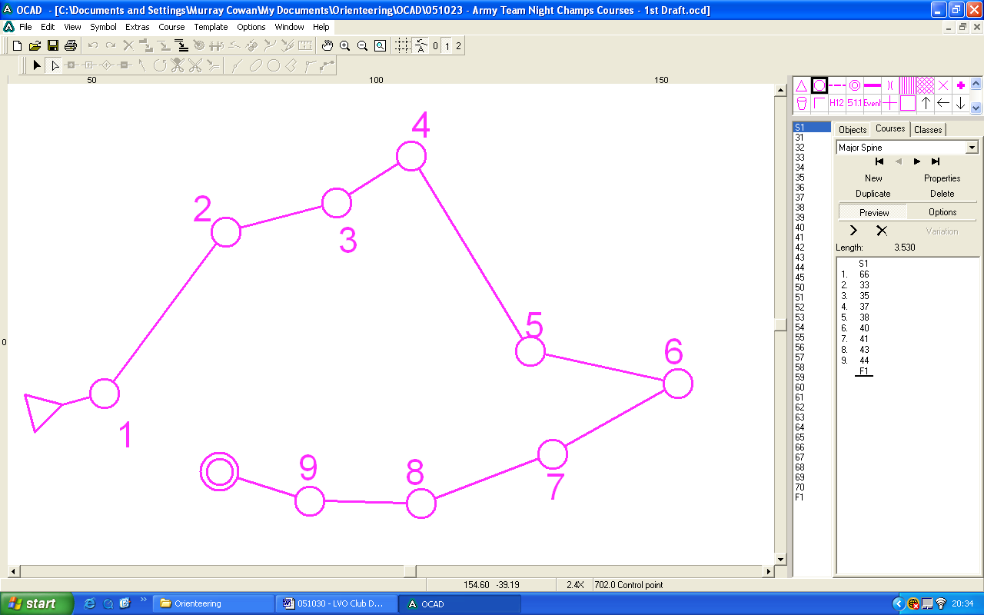
Ribbon Searching – covers only linear features and the land on either side. If missing person is using whistle then chance of being heard from linear feature exists.

Sectoring – terrain divided into areas which are then comprehensively sweep searched. This is thorough but very slow and labour intensive – invariably more than available.
1.
7.
6.
5.
4.
3.
2.

- If the Police have not yet been tasked, then they should be if nothing is found during the initial searches.

- It may be that the lead on the search is handed over to the Emergency Services at some stage. In this case, the officials nominated in the Emergency structure in Step 1 are to provide an update on:
  - what has happened,
  - what action has been taken so far,
  - what documentation is being maintained including maps and
  - where the search is currently focused.

- Once Emergency Services have been briefed, club members will continue in support of the Emergency Services until the missing person is found & recovered.

- If it seems that this may be protracted then additional volunteers will be needed to replace those already committed (who will be tired).

Step 1 -  Informing the Decision | Step 2 -  Preparing the  Search | Step 3 -  Conducting the Search | Step 4 -  Concluding the Search

- Once the missing person is found:

  - 1st aid equipment must be got there ASAP with trained 1st Aider and additional helpers.
  - The missing competitor is likely to be worried, frightened, upset, disorientated, tired, hungry, cold and wet.
  - The Search Team approaching him/her must be sympathetic and reassuring, use his/her name – do not add to the fear and do not chastise.
  - Missing person must receive any basic treatment necessary to prevent worsening of their condition and provide comfort until evacuation.
  - Such treatment must include 1st aid, food, warmth and shelter – the missing person must not be left alone once found.
  - Only attempt to move the missing person if you can do so without exacerbating any injury and without any risk to the Search team.
  - Evacuate the person as directed by Emergency services.

- The recovery of the Emergency Search must be controlled to prevent any further complications.

- The priority lies initially with the safe recovery of the missing person followed by the recovery of the Search Teams.

- The Controlling Officials need to carefully account for all involved in the search and other activity. This is especially important if it is now dark.

- All organisations informed now need to be informed that the search has ended. Families/relatives must not be forgotten.

- The BOF Incident Form needs to be completed – ideally before people disperse although circumstances at the time will always dictate. This must be sent to BOF Office within 1 week of the incident.

- In due course, the Club will need to examine the incident with all involved. This is not to be any sort of witch-hunt – rather it is to ensure that there is a clear understanding of what actually happened and what, if anything, can be learned.

Responsibility in BOLD - suggested Event Official in brackets.
The most experienced Event Official should assume the responsibilities to Control the emergency.

