WELSH CHAMPIONSHIPS 2014

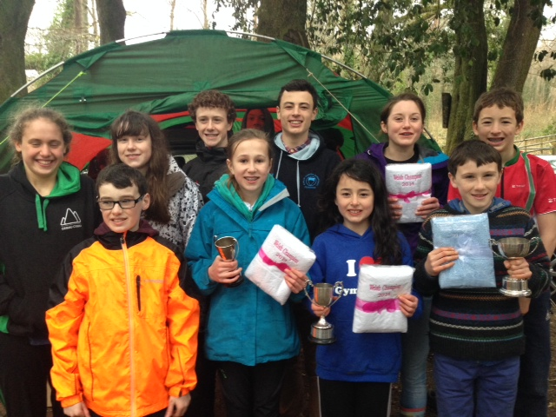

L-R: Nancy Dingle, William Thomas, Emily Thomas, Joe Thomas, Catrin Skym, Daniel Thomas, Hannah Thomas, Megan Carter-Davies, Harry Thomas, Dafydd Thomas. Young Prize-winners and competitors From MWOC at the Welsh Champs 2014.

