Blue Course
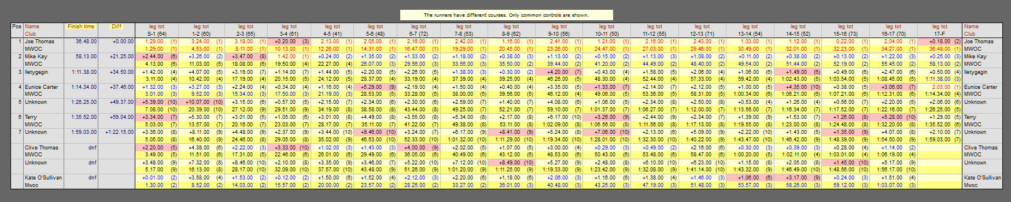
L.Green Course
Orange Course
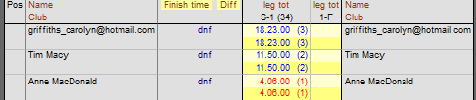
Yellow Course
Please note these results were taken directly from Usynligo and transferred to winsplits for publication. For those competitors who were not shown a finish time is because somewhere along their course they did not get a registration response from a control. For those who completed the course but are not shown in the results is because they have not shared their results on the app. If you read this message could you amend your settings on the app to share and then post to the email address shown on the website. We will then update the results accordingly. With reference to the unknowns, could you check when you log on to your app that you gave a name?
Getting results published correctly is an ongoing exercise, the app developer has promised to look into this. The results you see on your own mobile phone are correct but it is the process of taking the xml file and publishing it in a readable form where the problem exists.
We will endeavour to bring these results up to date but meantime would please send your individual results to us if you have not already done so.

